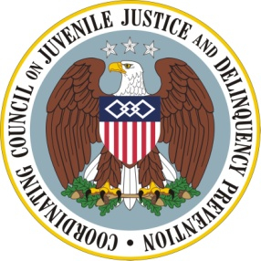
DRAFT DRAFT DRAFT DRAFT DRAFT DRAFT DRAFT

Coordinating Council on Juvenile Justice and Delinquency Prevention Quarterly Meeting

Friday, October 21, 2011

U.S. Department of Justice, Office of Justice Programs
810 Seventh Street NW, 3rd Floor Conference Center, Washington, DC 20531

10:00–10:05 a.m. Welcome and Opening Remarks
Eric H. Holder, Jr., Attorney General and Coordinating Council Chair

10:05–11:20 a.m. Strengthening Military Families
Robert Gordon, Deputy Assistant Secretary of Defense (Military
Community and Family Policy) Office of Children and Youth
Barbara Thompson, Director, Office of Family Policy/Children and Youth
Dr. Mary Keller, President and CEO, Military Child Education Coalition
Dr. Anita Chandra, Manager, Behavioral and Social Sciences Group, RAND
Corporation
Dr. Patricia Lester, associate professor, child and adolescent psychiatry,
UCLA and the director of Families Overcoming Under Stress

11:20 – 11:35 a.m. Break

11:35 a.m. – 12:25 p.m. Agency Announcements and Updates
Keeping Kids in Class: Announcement and Update on the Supportive School Discipline Initiative
Attorney General Holder
Kristen Harper, Senior Policy Advisor, U. S. Department of
Education
HUD and GreatSchools: Coordinating to Help Inform Families’ Housing and Education Decisions
Luke Tate, Senior Advisor for Urban Policy, U. S. Department of
Housing and Urban Development
Natanya Levioff, GreatSchools of D.C.
White House Council on Community Solutions
Leslie Boissiere, Executive Director

12:25–12:30 p.m. Summary and Meeting Adjournment
Attorney General Holder

