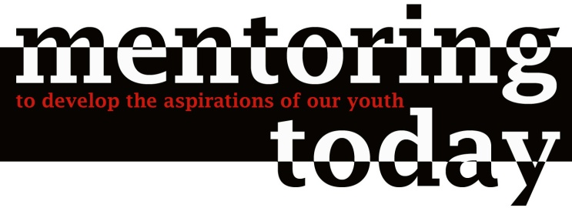

Our Mission
Mentoring Today serves youth who are returning from incarceration and reintegrating into the DC community. We provide them with dedicated mentoring and advocacy services as they strive to establish safe and fulfilling lives. The aim of Mentoring Today is to empower DC’s at-risk youth to recognize their dreams and live their aspirations.

Our Goals
- Reduce the rate at which youth return to criminal behavior.
- Increase the education and employment levels of our youth participants.
- Promote positive youth development.

FREE Project
In 2010, one of our most successful mentees, Brandon, launched an exciting youth empowerment project called FREE, which stands for Fighting for Rights, Education, and Employment. FREE recruits Youth Leaders from among Mentoring Today’s mentees and provides them with an opportunity to give back to the youth at New Beginnings and in the community.

The FREE Project has recently:
- facilitated discussions with New Beginnings residents to talk about the challenges of being locked up and how to prepare for re-entry;
- conducted surveys with New Beginnings residents to give feedback to DYRS on New Beginnings and community-based services; and
- developed recommendations for DYRS leadership to improve New Beginnings and community-based services.

Through FREE, youth receive the concrete tools and support they need to reach out to their peers and promote positive change in their communities. As they act as peer mentors and role models, they show that when Mentoring Today mentors one youth and helps him get on the right path, the lives of dozens of other youth can be positively affected.

