**OJJDP’s Youth Violence Prevention Initiatives**

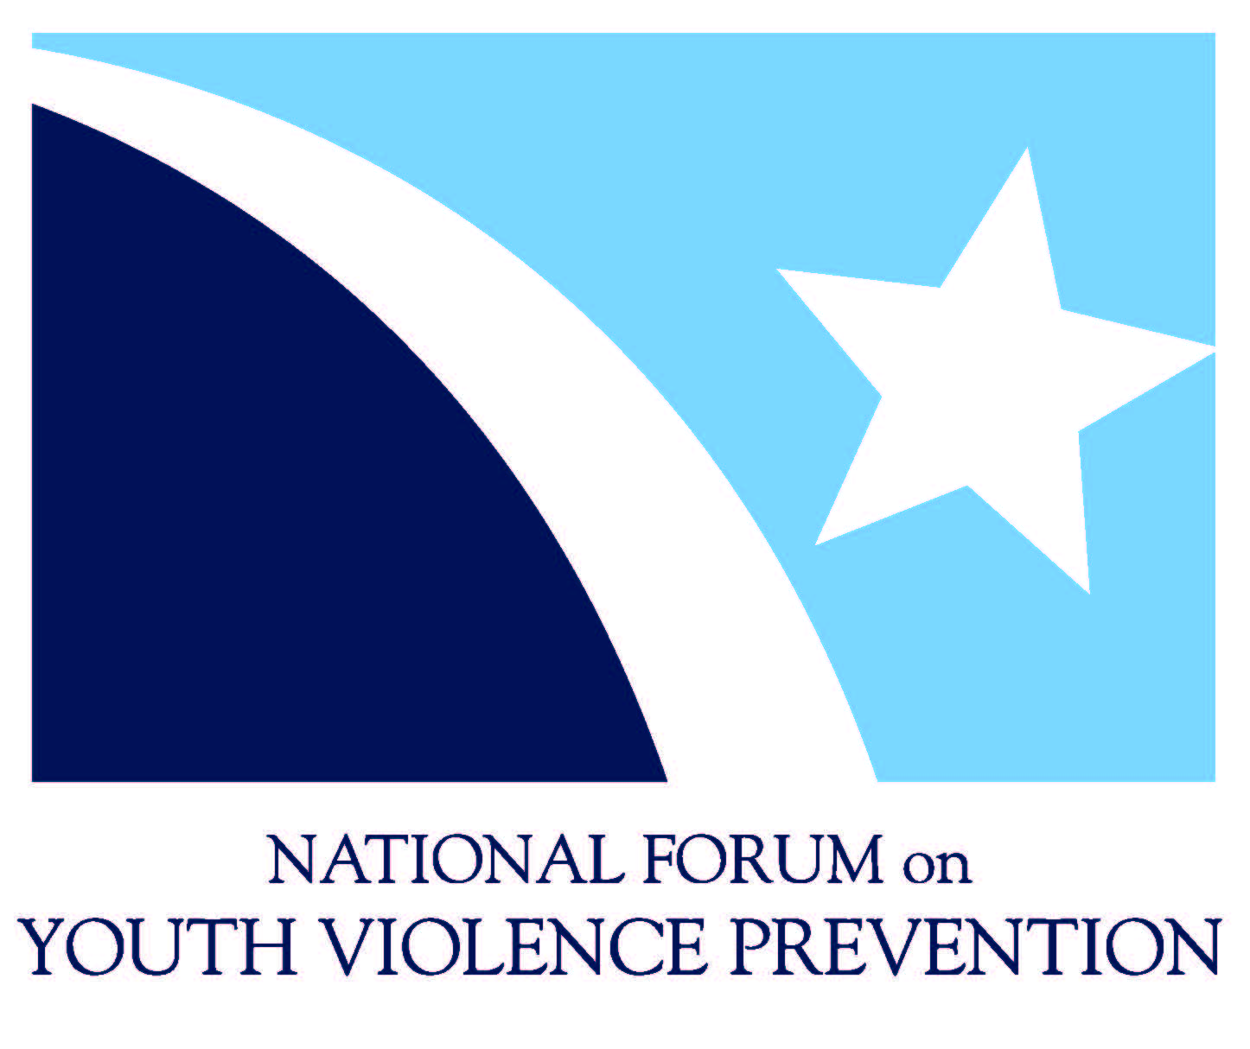The Office of Juvenile Justice and Delinquency Prevention (OJJDP) has funded three key initiatives and -- with the Centers for Disease Control and Prevention (CDC) -- constructed a framework for action to help communities reduce and prevent youth violence. Each youth violence initiative was launched in 2010 to address various facets of violence and to mitigate the consequences of trauma to children and youth through evidence-based and promising programs, practices, and strategies. Collectively, OJJDP’s initiatives provide a comprehensive, balanced road map to promote the well-being of children and youth through the elimination of violence and victimization.

**The National Forum on Youth Violence Prevention (Forum)** represents a network of 15 communities and federal agencies that work together, share information, and build local capacity. Communities use prevention, intervention, enforcement, and reentry strategies to stop violence and sustain their accomplishments. The Forum is supported by a Federal Coordinating Team that includes the U.S. Departments of Justice, Education, Housing, Labor, and Health and Human Services and the Centers for Disease Control and Prevention (CDC), among others, to align efforts and resources.

**The Community-Based Violence Prevention Program (CBVP)** concentrates on stopping youth gang and gun violence in 16 cities through evidenced-based deterrence and public health approaches. CBVP is characterized by partnerships among law enforcement, service providers, residents, and community- and faith-based organizations.

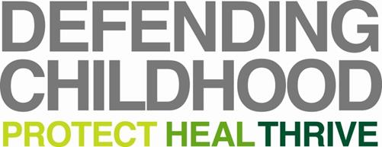**The Defending Childhood Initiative** seeks to prevent and more fully understand the impact of trauma resulting from children’s exposure to violence (CEV). CEV is associated with long-term physical, mental, and emotional harm, and puts children and youth at greater risk of failing in school and employment; future victimization; and future involvement in the juvenile and criminal justice system. To interrupt the cycle of violence and its negative consequences, the Department of Justice awarded grants to six communities and two tribal nations to implement evidence-based treatment, community-based solutions for violence prevention; and to revise policies and practices within the public systems that serve children and families.

|  |  |  |
| --- | --- | --- |
| **National Forum on Youth Violence Prevention** | **Community-Based Violence Prevention Program** | **Defending Childhood Initiative** |
| Baltimore, MD | Baltimore, MD | Boston, MA |
| Boston, MA | Baton Rouge, LA | Chippewa Cree Tribe, MT |
| Camden, NJ | Boston, MA | Cuyahoga County, OH |
| Chicago, IL | Brooklyn, NY | Grand Forks, ND |
| Cleveland, OH | Camden, NJ | Multnomah County, OR |
| Detroit, MI | Denver, CO | Portland, ME |
| Long Beach, CA | Detroit, MI | Rosebud Sioux Tribe, SD |
| Louisville, KY | Kansas City, MO | Shelby County, TN |
| Memphis, TN | Los Angeles, CA |  |
| Minneapolis, MN | Newark, NJ |  |
| New Orleans, LA | Newport News, VA |  |
| Philadelphia, PA | Oakland, CA |  |
| Salinas, CA | Philadelphia, PA |  |
| San Jose, CA | Prince George’s County, MD |  |
| Seattle, WA | Syracuse, NY |  |
|  | Washington, DC |  |

**Shared Framework**

The Shared Framework to Reduce Youth Violence and Promote Well-Being (Shared Framework), which was developed by CDC and OJJDP, is designed to facilitate understanding and collective action by those whose efforts influence and contribute to safe and nurturing families and communities (For more information, visit <https://prezi.com/gy8vvmv4j3zz/copy-of-shared-framework-reducing-youth-violence/>). The Shared Framework sets forth a unifying paradigm and common language for those working to reduce youth violence and help children and youth thrive. It describes values, action principles and a theory of change that is built on three decades of research and practice. The Shared Framework can serve as a tool for all those seeking to bring about productive change and to sustain what works and is being used to help OJJDP sites, CDC grantees and federal, state, and local partners of the initiatives broaden and enhance their efforts.

**Technical Support**

OJJDP and its federal partners provide oversight and capacity building to the funded communities through a wide range of training and technical assistance, including strategic planning, webinars, resource materials, peer-to-peer learning, and onsite visits. Notably, OJJDP has convened National Summits in 2011, 2012 and 2013, an Implementation Science Training Institute in 2014, and annual gatherings of the Defending Childhood sites. These events bring together local leadership from the key sectors of education, public health, law enforcement, and child welfare with federal staff, technical assistance providers and evaluators to help advance the necessary commitments, systems changes, and resource allocation to reduce youth violence. In 2014, OJJDP established a coordinated training and technical assistance effort to facilitate further alignment and cross-initiative learning.

**Outcomes**

Over the past three years, the number of sites participating in these initiatives increased to 39. Using a range of violence prevention and other collective-impact strategies, these communities have realized achievements -- including self-reported reductions in violence -- that may be attributed to these programs. Each reflects a growing commitment to finding comprehensive methods to prevent youth violence and enhance youth development:



**The National Forum** cities reported reductions in homicides and juvenile violent crime in 9 out of 10 cities during 2014. In one Forum city, violent crime decreased by 22 percent last year. Nonfatal shootings have also dropped from previous years in these cities. Additionally, some cities report changes in quality-of-life measures such as increased school retention, better police practices, passage of state legislation to leverage resources**,** and passage of local tax measures. For more information, visit <http://www.findyouthinfo.gov/youth-topics/preventing-youth-violence>.

**The Community-Based Violence Prevention Program** cities reported reductions in gun violence, increases in community engagement, and substantial impacts on community norms regarding gun violence. In one example, the average monthly shooting rates in Crown Heights (in Brooklyn, N.Y.) decreased by 6 percent, while shootings increased between 18 percent and 28 percent in three comparison neighborhoods. In Baltimore during the last reporting period (July through December 2014), there were five shooting incidents—a 50 percent decrease from the same period during the previous year. Other outcomes include 41 instances of mediated conflicts that likely would have resulted in violence.

**The Defending Childhood initiative** grantees used innovative approaches with local practitioners and community members to define the nature of children’s exposure to violence locally and to tailor solutions accordingly. Agencies successfully developed innovative treatment, prevention and intervention strategies, updated procedural manuals and protocols and supported training to help workers recognize the impact of childhood exposure to violence. In addition the initiative has built local capacity by supporting more than 600 professional trainings, 723 community awareness/education events, and 538 publications and advertisements (October 2011 through September 2014*). *Please note these numbers are based on six sites that participated in the evaluation by the Center for Court Innovation. For more information on Defending Childhood, visit <http://www.defendingchildhood.org>.