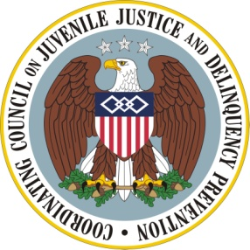

Coordinating Council on Juvenile Justice and Delinquency Prevention
Quarterly Meeting

Friday, May 11, 2012

U.S. Department of Justice, Office of Justice Programs
810 Seventh Street NW, 3rd Floor Conference Center, Washington, DC 20531

10:00–10:10 a.m. Welcome and Opening Remarks
Attorney General Eric H. Holder, Jr., Chair, Coordinating Council

10:10–10:40 a.m. Update on Changing Practice: Family and Field Perspectives
Moderator: Sue Badeau, Director, Knowledge Management, Casey Family
Programs
Grace Bauer, Co-director, Justice for Families
Grace Warren, Co-director, National Parent Caucus
Shay Bilchik, Director, Center for Juvenile Justice Reform, Georgetown University

10:40-11:00 a.m. One Year Later: Family Engagement and Partnering
Melodee Hanes, U. S. Department of Justice, and Vice Chair, Council
David Esquith, U. S. Department of Education
Martha Moorehouse, U. S. Department of Health and Human Services (HHS)
Larke Huang, Substance and Mental Health Services Administration, HHS
11:00-11:15 a.m. Break

11:15 -11:50 a.m. Panelist Comments and Discussion of Family Engagement
Moderator: Judge Trina Thompson, Immediate Past Presiding Judge,
Juvenile Court, Alameda County, and Council Practitioner Member

11:50-12:10 p.m. Agency Announcements and Updates
Information Sharing Committee
Mark Sakaley, Co-Chair
Other Announcements and Updates
Kathie Soroka, U. S. Department of Housing and Urban Development

12:10 to 12:15 p.m. Summary and Meeting Adjournment
Eric H. Holder, Jr., Chair

