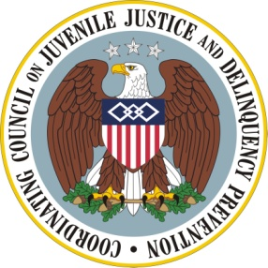

Coordinating Council on Juvenile Justice and Delinquency Prevention
Quarterly Meeting
Thursday, July 21, 2011

U.S. Department of Justice, Office of Justice Programs
810 Seventh Street NW, 3rd Floor Conference Center, Washington, DC 20531

10:00–10:10 a.m. Welcome and Opening Remarks
Jeff Slowikowski, Coordinating Council Vice Chair

10:10–10:40 a.m. Approval of the Recommendations of the Issue Teams
Mr. Slowikowski, Vice Chair and Operations Committee Chair

10:40–11:55 a.m. Moving to Win-Win with Federal-Family Partnerships
Lisa Lauxman, U.S. Department of Agriculture, Moderator
Diana Denboba, U. S. Department of Health and Human Services, Health
Resources and Services Administration
Nora Wells, Family Voices
Grace Warren, National Parent Caucus
Brandon M., FREE Project/Mentoring Today
Sue Badeau, Senior Fellow, OJJDP

11:55 a.m. – 12:10 p.m. Break

12:10–12:25 p.m. Agency Announcements and Updates
The Supportive School Discipline Initiative
Attorney General Holder and Education Secretary Arne Duncan
Civic Justice Corps
Richard Morris, U. S. Department of Labor
Other Announcements

12:25–12:30 p.m. Summary and Meeting Adjournment
Eric H. Holder, Jr., Attorney General and Coordinating Council Chair

