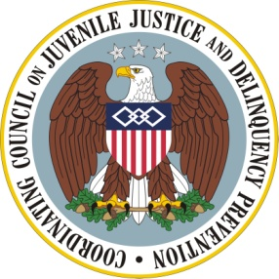

Coordinating Council on Juvenile Justice and Delinquency Prevention
Quarterly Meeting

April 12, 2013

U.S. Department of Justice, Office of Justice Programs
810 Seventh Street NW, 3rd Floor Conference Center, Washington, DC 20531

10:00–10:15 a.m. Welcome, Opening Remarks, and Introductions
Eric H. Holder, Jr., Attorney General, U.S. Department of Justice (DOJ)
Chair, Coordinating Council

Tony West, Acting Associate Attorney General, DOJ

Robert Listenbee, Jr., Administrator, Office of Juvenile Justice and Delinquency Prevention (OJJDP), DOJ, Vice Chair, Coordinating Council

10:15–11:30 a.m. Council Member Discussion: Implementing Recommendations of the Attorney General’s Task Force on Children Exposed to Violence
Moderator: OJJDP Administrator Robert Listenbee, Jr., Vice Chair

U.S. Department of Health and Human Services

Additional Agency Briefings/Comments

Practitioner Comments

11:30–11:40 a.m. Agency Announcements

U.S. Department of Housing and Urban Development (HUD)
Maurice Jones, Deputy Secretary, HUD

Additional Announcements

11:40 –11:45 a.m. Summary and Meeting Adjournment
Tony West, Acting Associate Attorney General, DOJ

