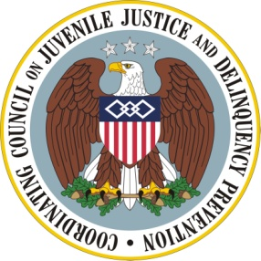
Coordinating Council on Juvenile Justice and Delinquency Prevention
Quarterly Meeting
Monday, May 23, 2011

U.S. Department of Justice, Office of Justice Programs
810 Seventh Street NW, 3rd Floor Conference Center, Washington, DC 20531

2:30–2:35 p.m. Welcome and Opening Remarks
Eric H. Holder, Jr., Attorney General and Coordinating Council Chair

2:35–3:55 p.m. School Discipline, Juvenile Justice and Delinquency Prevention
Moderator: Elizabeth Albro, U.S. Department of Education
Council on State Governments’ Texas School Records Study
Michael Thompson, Council of State Governments

Evidence-Based Approaches to Alternatives to Zero Tolerance and Effective School Discipline Practices
Kristin Moore, Ph.D., and Chris Boccanfuso, Ph.D., Child Trends

Liberty LEADS Dropout Prevention and College Access
Farhad Asghar, Bank Street College of Education

3:55–4:05 p.m. Break

4:05–4:20 p.m. Update on Consolidated Report: Action Items
Jeff Slowikowski, U.S. Department of Justice, Office of Juvenile Justice and Delinquency Prevention and Coordinating Council Vice Chair

4:20–4:50 p.m. Agency Announcements and Updates
Casey Family Programs: Crossover Youth Agenda
Eric Steiner, Casey Family Program
Sue Badeau, Todd Shenk, Annie Blackledge, Federal Fellows

National Forum on Youth Violence Prevention
Thomas Abt, U.S. Department of Justice, Office of Justice Programs

Father’s Day 2011
Helen Kanovsky and Ron Ashford, U. S. Department of Housing and Urban Development

4:50–5:00 p.m. Summary of Next Steps, Closing Remarks
Jeff Slowikowski, Vice Chair

