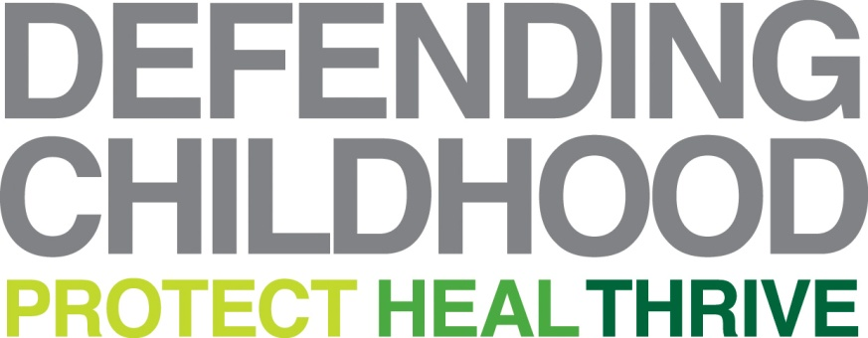

Background on the Attorney General’s Task Force on American Indian and Alaska Native Children Exposed to Violence

At the 2013 White House Tribal Nations Conference, Attorney General Eric Holder announced the creation of the Attorney General's Task Force on American Indian and Alaska Native Children Exposed to Violence.
This task force is anchored by a federal working group and an advisory committee of experts. Both were appointed to examine the scope and impact of violence facing American Indian and Alaska Native children and make policy recommendations to Attorney General Holder on ways to address it.
This working group includes ffederal officials from key agencies involved in issues related to American Indian and Alaska Native Children Exposed to Violence: Department of Justice (including U.S. Attorneys in Indian country), Department of Interior, and Department of Health and Human Services.
The advisory committee is comprised of child welfare practitioners, child and family advocates, academic experts, and licensed clinicians. Byron Dorgan, former U.S. Senator and chair of the Senate Committee on Indian Affairs, and Joanne Shenandoah, Iroquois, composer and musical artist, are Co-Chairs of the advisory committee.
This Task Force is part of the Attorney General's Defending Childhood Initiative, a project that addresses the epidemic levels of exposure to violence faced by our nation's children. The task force was created in response to a recommendation in the Attorney General's National Task Force on Children Exposed to Violence Final Report, December 2012, which drew attention to American Indian and Alaska Native children’s exceptional degree of unmet needs for services and support to prevent and respond to the extreme levels of violence in their lives.
Based on the testimony at four public hearings and five listening sessions, on comprehensive research, and on extensive input from experts, advocates, and impacted families and communities nationwide, the Advisory Committee on American Indian Alaska Native Children Exposed to Violence issued a final report to the Attorney General presenting its findings and comprehensive policy recommendations on November 18, 2014. The full report is available at www.justice.gov/defendingchildhood/task-force-american-indian-and-alaska-native-children-exposed-violence.

Scope of the Advisory Committee’s Work

Four national public hearings. The advisory committee held four public hearings in Bismarck, N.D., December 2013; in Scottsdale, Ariz. at the Salt River Pima-Maricopa Indian Community, January 2014; in Fort Lauderdale, Fla., April 2014; and Anchorage, Alaska, June 2014. At the hearings, the advisory committee spoke with more than 70 experts from 15 states and the District of Columbia, including tribal officials, survivors of violence, young people, social service providers, medical personnel, researchers, practitioners, advocates, local elected officials and representatives of private foundations. The task force also heard from more than 60 members of the public during open sessions. Information on the hearings is available online at www.justice.gov/defendingchildhood.
Five community-based listening sessions. Representatives of the advisory committee hosted five community-based listening sessions in Scottsdale, Ariz. at the Salt River Pima-Maricopa Indian Community and Gila River Indian Community; in Minneapolis, Minn; and in Bethel, Napaskiak, and Emmonak in Alaska. The five sites chosen for the listening sessions represented tribal judicial systems, tribal youth councils, urban Indians, and Alaska Native villages. Over 50 community residents participated in informal group discussions with the advisory committee about their childhood exposure to violence as survivors, parents, community members, or professionals.
Open comment period for written testimony and input. In addition to testimony from hearings and listening sessions, the advisory committee heard from more than 50 individuals and organizations through a six-month public testimony submission period that closed on July 31, 2014.

Survey of current research. For the past ten months, the advisory committee has reviewed research on children’s exposure to violence and related fields to supplement the information provided through verbal and written testimony.
Final Report. The Advisory Committee presented their final report to the Attorney General at the November 18, 2014 meeting of the Coordinating Council on Juvenile Justice and Delinquency Prevention in Washington, DC. The report recommends a significant rebuilding of the current services provided to Indian Country, through increased federal partnerships and coordination with tribes, and increased funding for programs to support American Indian and Alaska Native children. The report delivers the Advisory Committee’s vision of how to develop effective, trauma informed, and culturally appropriate programs and services to protect American Indian and Alaska Native children exposed to violence.

